Business Performance Analysis for Zid
Mousa Alubaid
Date: 2024/10/28

Introduction:
This report aims to analyze the performance of stores using the Zid platform and provide recommendations for improving performance.

Task 1: Key Performance Indicators (KPIs) for Zid's Stores
Total Number of Stores: 3,851
I have attached an Excel file containing the KPI for each store.

Task 2: Analyze Shipping Methods and Delivery Performance

Introduction
Shipping is a critical component of store performance and customer satisfaction on the Zid platform. To optimize the shipping process, it is important to analyze the different shipping methods used by Zid's stores and identify the ones that provide the quickest delivery times and the lowest rates of order cancellations or delays.

Analysis of Shipping Methods
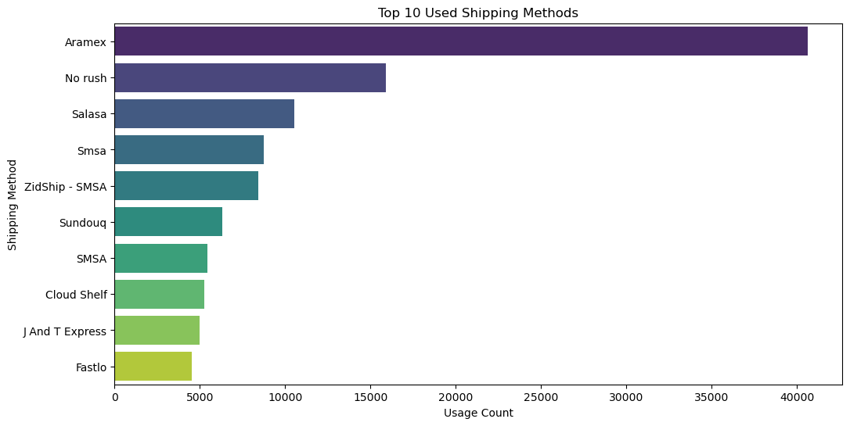
The chart shows the "Top 10 Used Shipping Methods" on the Zid platform.

Analysis of Delivery Times
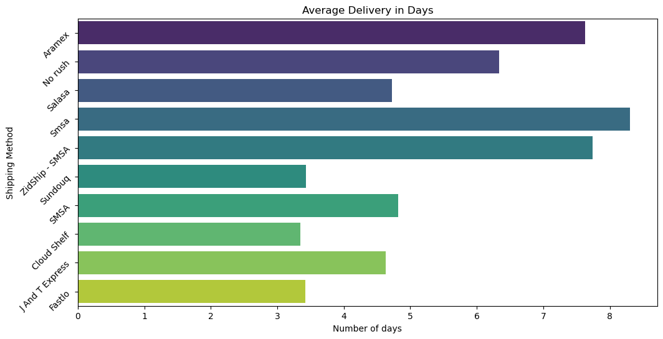
The graph shows the "average delivery time" for the top 10 most used shipping companies.
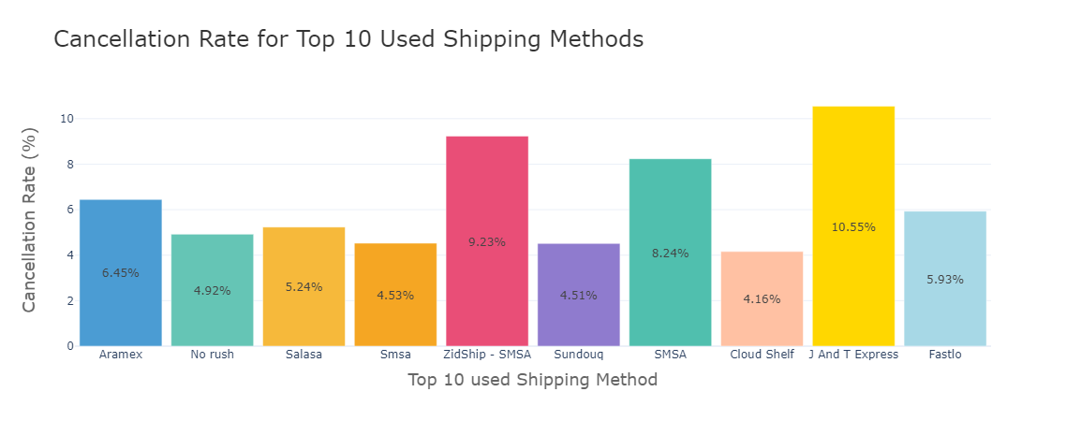
The chart displays the cancellation rates for each shipping method among the top ten most used shipping options.
Which shipping method provides the quickest delivery times?
Based on the provided graph, “Aramex” is the clear leader in terms of average delivery time, consistently delivering packages within a shorter timeframe compared to other shipping methods. This indicates that Aramex is a reliable and efficient shipping provider.

Are there any shipping methods associated with higher rates of cancellations or delayed deliveries?
For orders that have a minimum of 10 and a delay exceeding 10 days, here is the information I've gathered about the shipping methods.

I have attached the Excel file.

Provide your findings with supporting metrics and visualizations. Make recommendations for optimizing the shipping process for stores on the Zid platform?

Aramex stands out as a robust choice for stores on the Zid platform, demonstrating commendable performance in critical metrics such as cancellation and delay rates. This suggests a high level of reliability and efficiency in their service delivery.

recommend that stores experiencing high cancellation rates consider partnering with Aramex to enhance their operational performance. Stores facing high cancellation rates or delays should consider partnering with Aramex to improve their operational performance. This collaboration could enhance reliability and efficiency in service delivery, ultimately leading to better customer satisfaction.

Additionally, the "ZidShip” service appears once in the top ten shipping companies utilized by customers, holding a notable fifth position. However, it also experiences a high cancellation rate. This combination of factors underscores the opportunity for further development and enhancement of this product.

Task 3: Customer Segmentation and Store Strategy
Segment customers

RFM analysis is recognized as one of the best methods for customer segmentation. I utilized this approach to segment customers based on their ordering behavior.

In this analysis, Recency was calculated as one day after the last recorded order.
The accompanying chart will illustrate the segmentation results obtained from this analysis, highlighting key insights into customer behavior and value.
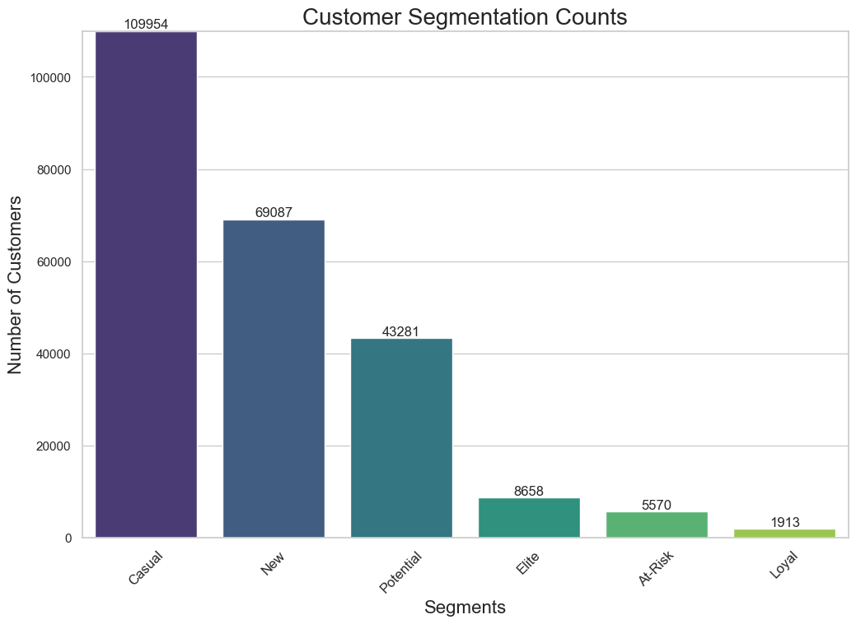
Casual Customers: Occasional buyers who need incentives to shop again. Focus on special offers and enhancing their experience.
New Customers: First-time buyers. Encourage repeat purchases with discounts and personalized product recommendations.
Potential Customers: Customers who could become loyal. Engage them with loyalty programs and exclusive offers to boost spending.
Elite Customers: Top buyers with high spending. Provide personalized services and early access to promotions.
At-Risk Customers: Customers who haven't purchased in a while. Re-engage them with targeted campaigns and special deals.
Loyal Customers: Frequent buyers. Reward their loyalty with exclusive benefits and tailored recommendations.
Store category trends: Which store categories (e.g., fashion, pets supplies) attract the most customers and orders?

Analysis of Store Categories Trends
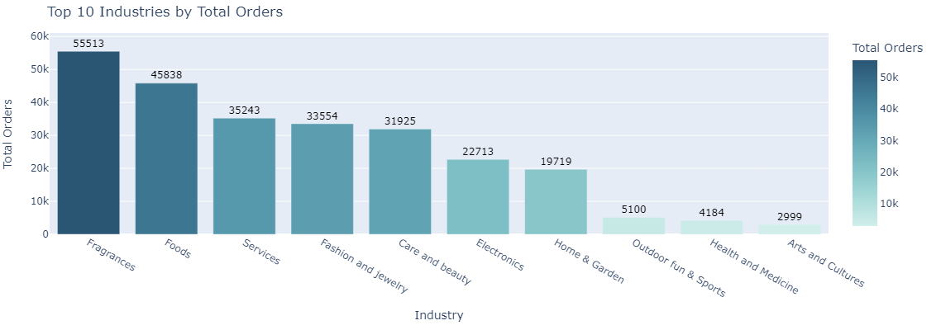
This chart shows the analysis of customer purchasing behavior based on the number of orders for each category.

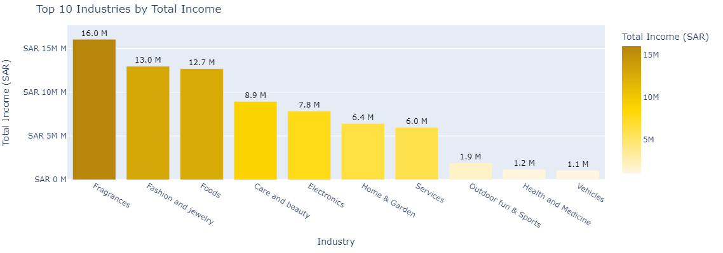
The chart above shows the top 10 industries by total income, measured in Saudi Riyals. We can observe that the perfume industry ranks first.

Opportunities and Challenges: What are the available opportunities in the industries that have performed well? What challenges do the underperforming industries face?

Focus on Top-Performing Industries: Targeted Marketing: Develop targeted marketing campaigns for the top-performing industries, such as fragrances, fashion, and food.
Support Underperforming Industries: Product Curation: Help stores curate their product offerings to focus on high-demand items and niche products.

Task 4: Stores Challenges and Recommendations

Challenges

1. Incorrect Data Entry
Issues with data entry from store owners and shipping companies can significantly impact operational efficiency and accuracy. This can lead to:
Misleading Insights: Inaccurate data may produce skewed reports, affecting decision-making and strategic planning.
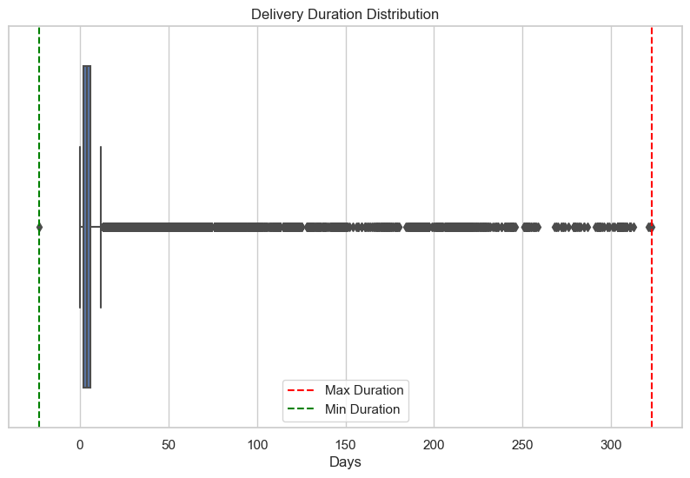

The chart shows that most orders were delivered within a relatively short time frame. However, there are some outlier data points, such as delivery times reaching up to 300 days or negative delivery days.
2. Order Cancellations
Cancellations may arise from factors related to either the store or the shipping company, including:
Inventory and Processing Issues: Poor inventory management and slow order processing can result
in cancellations, especially when items are out of stock.
Shipping-Related Delays: Delays caused by shipping companies, such as late deliveries or
lost packages, can also lead to cancellations.

3. Handling New Orders
Efficient management of new orders is essential for operational success. Key challenges include:
Order Processing Delays: Slow processing of new orders can hinder overall efficiency
and lead to missed sales opportunities. Prompt order fulfillment is critical for maintaining
customer satisfaction and trust in the platform.

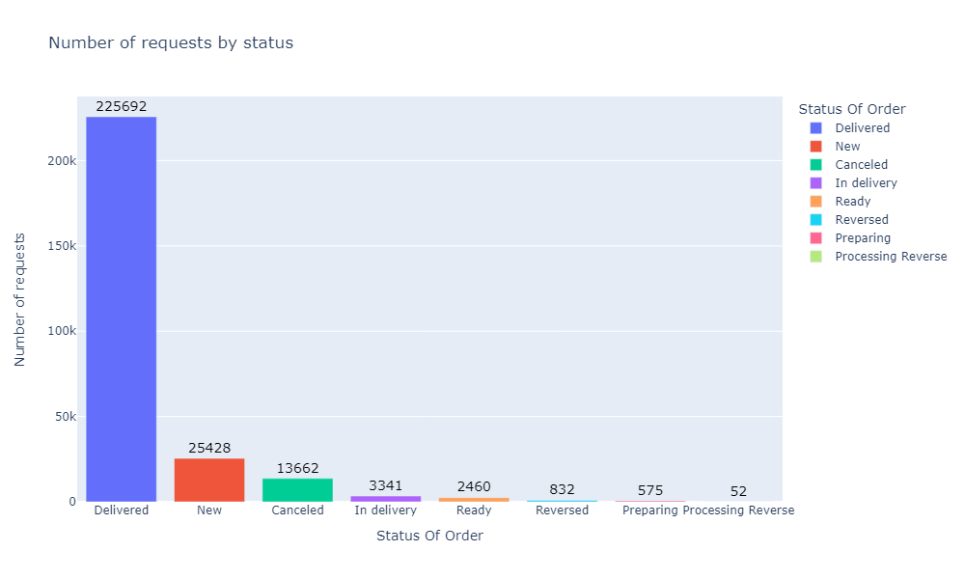
The chart indicates the number of orders that have reached each status category. The "Delivered" status shows the highest number of orders.
However, in this case, we cannot measure the transition from "New" to "in delivery"
because some orders do not require delivery.
4. Optimizing shipping methods
Effective shipping tracking is crucial for identifying and addressing operational challenges. For
Zid, leveraging accurate shipping data allows for:
Enhanced Reporting and Feedback: Robust tracking data enables Zid to generate insightful reports
for stores, promoting a better understanding of shipping performance and aiding logistics decisions.
Continuous Improvement: Regular reviews of shipping data empower Zid to implement
ongoing enhancements to logistics processes, ensuring high service standards and ultimately
leading to improved customer satisfaction and loyalty.

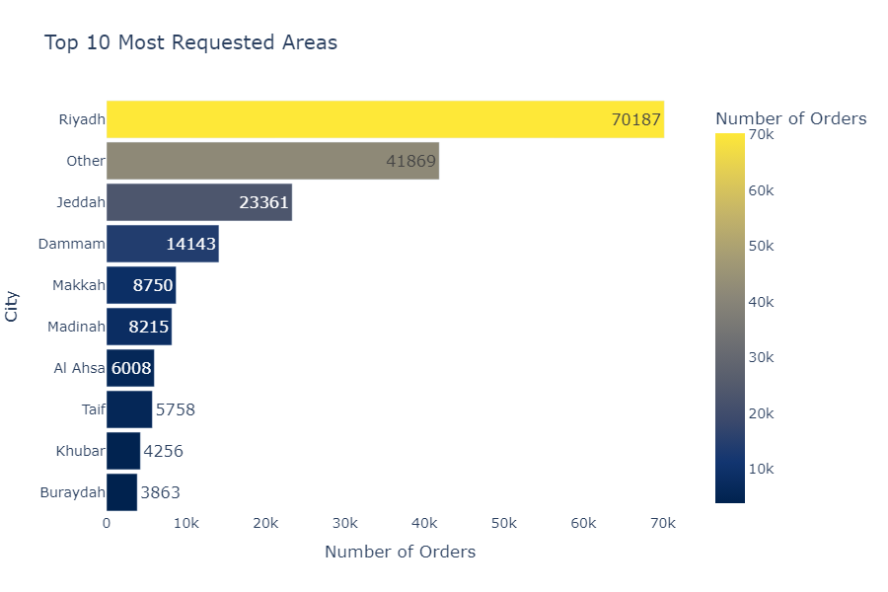
The chart shows the Most 10 City for shipments.

It also highlights a significant number of shipments categorized as "Other"

We will see in the following chart what is included in the "Other" category.

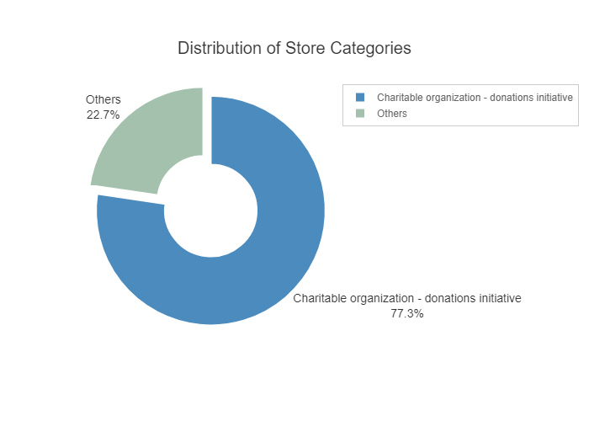
The contents of the "Other" Category

This indicates that the "Other" category contains a large number of requests related to "charities and donation initiatives"

Generally, these Order "charities and donation initiatives" Do not require delivery,
which complicates data analysis efforts.

Recommendation

Improving order fulfillment and reducing cancellations.
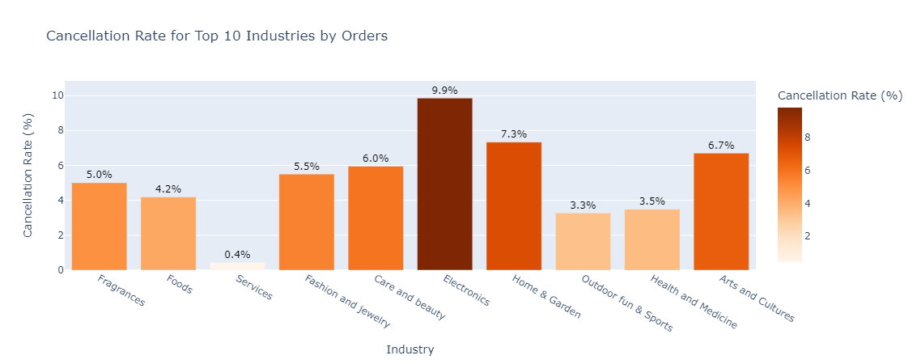The chart illustrates order cancellation rates among the top 10 most demanded industries.
Logistics Efficiency: The effectiveness of shipping and delivery operations plays a crucial role in determining cancellation rates.
Additionally, the lower cancellation rate in the "Services" industry may be attributed to the reduced need for delivery, resulting in fewer logistical challenges and, consequently, fewer cancellations.

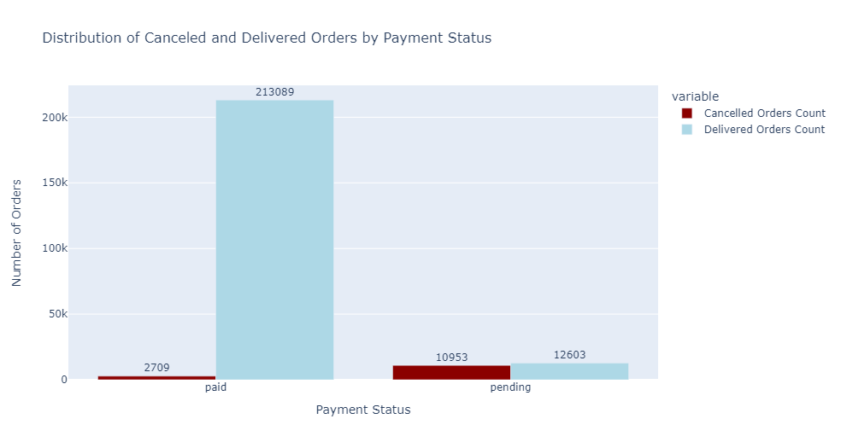
The chart clearly shows the relationship between payment status and order cancellations.
observe a notable reduction in cancellation rates when the payment status is marked as "Paid" compared to "Pending." This trend suggests that customers who complete their payments are more committed to finalizing their purchases.
To further minimize cancellations, it is crucial to ensure that there are no issues or disruptions during the payment process.
Recommendation:
Enhance the user experience by providing multiple secure and quick payment options. This improvement can streamline the checkout process, potentially increasing the order completion rate and reducing cancellations.

Optimizing shipping methods for faster and more reliable deliveries.
Faster Deliveries: Streamlining shipping methods can significantly reduce delivery times, ensuring that customers receive their orders promptly.
Increased Reliability: By choosing reliable carriers and optimizing logistics processes, businesses can minimize delays and enhance overall delivery reliability.
there are some shipping companies that show potential for further enhancement

Developing effective discount strategies to drive profitability.

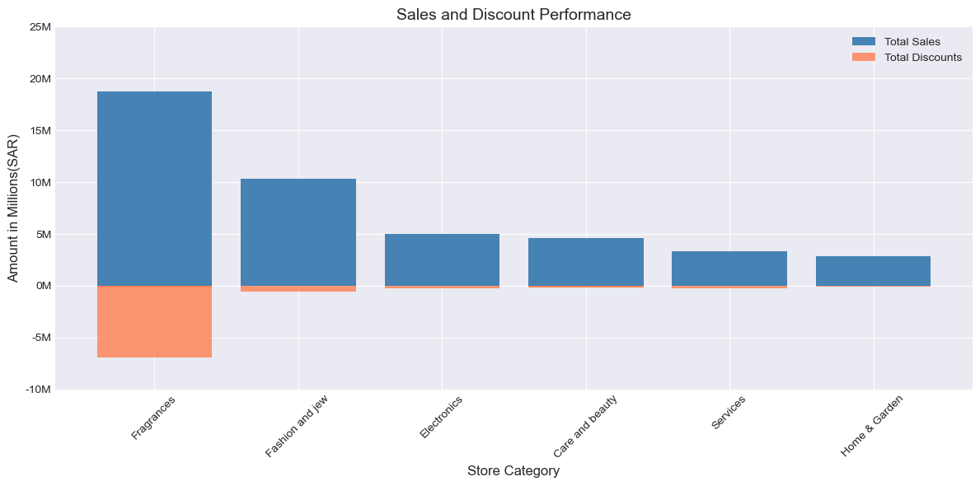

Highest Sales Category: The "Fragrances" category stands out as the top performer in total sales. This indicates that fragrance products are very popular among customers and generate the highest revenue.

Discounts: Although the "Fragrances" category has the highest sales, it also offers the highest percentage of discounts. This may suggest that using discounts as a marketing tool is effective in attracting customers in this category.
Influencing factors: There are other factors that may affect sales and discounts such as season, competition, marketing campaigns, and product availability.
But this data is only for 8 days.

Targeting high-value and repeat customers with personalized offers.

User Segments

Benefits for Zid:
Deeper Data Analysis: Enables better understanding of customer behavior, contributing to improved marketing strategies.
Increased Engagement with Stores: Provides accurate data that helps stores enhance performance and boost revenue.

Benefits for Stores:
Customized Marketing Strategies: Allows for targeted offers for each customer segment, increasing sales opportunities.
Enhanced Customer Experience: Fosters customer loyalty by offering promotions that align with their needs and preferences.

Benefits for Customers:
Motivation for Advancement: Customers are incentivized to reach higher segments to unlock additional benefits, such as cash-back offers and exclusive promotions.
Enhanced Personalization: Customers enjoy a tailored experience, receiving offers that resonate with their preferences, making them feel valued and understood.

More Recommendations

Incorrect Data Entry:
User-Friendly Interfaces: Design user interfaces that are intuitive and easy to navigate, reducing the chances of errors during data entry.
Training and Awareness: Conduct regular training sessions for staff on the importance of accurate data entry and best practices

Optimizing shipping methods Response Times:
Adding a field to indicate whether an order requires a shipping Method for delivery could simplify tracking and data analysis. This would allow for more accurate insights into delivery processes and improve overall efficiency.
Improved Data Analysis: Facilitates better tracking of orders that require delivery versus those that do not.
Enhanced Efficiency: Streamlines the logistics process by clearly indicating shipping needs, allowing for more accurate planning and resource allocation.

Enhancing Shipping Tracking:
Adding information about the shipping origin to the delivery destination would enhance the accuracy of shipping tracking and analysis. This additional data would facilitate better insights into the shipping process, allowing for more precise development and optimization strategies.
Add Customer Ratings for Shipping Companies: Implement a feature allowing customers to rate the shipping company for each order. This feedback can provide valuable insights into the shipping experience and help identify areas for improvement.
Add Store Ratings for Shipping Companies: Enable stores to evaluate shipping companies directly within the platform. This can foster accountability and encourage shipping companies to enhance their services based on store feedback.
KPIs for Stores:
Implement a KPI to measure the speed of order fulfillment, specifically tracking the time taken for orders to move from the "New" status to the "In Delivery" status. This metric will help assess operational efficiency and improve the overall customer experience.

